**Data analytics in football to analyse effect on trends in different locations**

**References:**

<https://www.ijrte.org/wp-content/uploads/papers/v7i4s2/ES2081017518.pdf>

**Abstract:**

Football is often called the world’s biggest sport. Data Analytics has become pivotal in the world of Football. It has transformed how people approach games, team formation, player selection etc. Data analytics has enabled teams from around the world to understand their game better and perform better. Data analytics is also used to predict the outcomes of games enabling people to make educated guesses while betting. Even though football is a global sport, there are a few national teams that don’t even manage to make into the main tournaments like FIFA. It is very important for a Football enthusiast to know that the game keeps evolving towards a point where there are more quality teams around the world. It is very important for data analytics to move into this direction of finding answers to the question “What can be done to provide quality opportunities to the teams worldwide?”. The present paper discusses exactly that and looks to provide an answer to that very question.

**Introduction:**

Football game was always the most famous and popular sport in various European and South American countries that has been played and viewed. The popularity of the sport, however, recently started booming in the Indian subcontinent since the early 21st century, probably owing to the popularity of televisions and global broadcasting of the games. Data analytics has helped in many ways in the game. The first ever international match was played in 1872 between two neighbouring countries – England vs Scotland. The match ended in a 0 – 0 draw. 146 years later the game of Football has grown from its roots in Europe to reach all around the world with 211 national men’s teams currently playing every year. Data Analytics is playing a big role in the game of football. Current systems are being used to predict outcomes in a game which is made useful by people for betting on their teams. People are able to make an educated guess on who would win a match thus enabling their chances of making money. Data Analytics is also used to extract hidden information in the game. This enables team managers, coaches and the players understand their own game better, their mistakes, their opponent’s strategies, weaknesses, etc. This paper discusses how a geographical analysis is done to understand where international football matches are played. It is done also by looking at where the FIFA World Cup matches played.

**Motivation:**

Football game was always the most famous and popular sport in various European and South American countries that has been played and viewed. With the popularity of global and television broadcasting of the games, football game recently started to popularize in the Indian subcontinent since the early 21st century. India is steadily becoming a global figure in the Football (American: Soccer) world, with more and more official football events happening and also major international stars participating in the new Indian Super League.

In football, performance can be defined as the interaction of different factors such as technical, tactical or even mental. Players are improving; Managers are able to make good decisions, be it strategic or tactical. The game of football itself is growing so much so that it has now become one of the most if not the most popular sport in the world. Billions watch, millions play. To ensure successful execution of all tactics, a coach has to take into account the status of the team, the status of the opposition, as well as external factors like playing at home or even the weather. This is a place where Data Analytics plays a big role. Teams can be assessed based on different factors to define a winning strategy for the game. A lot of teams have either failed to catch on or have failed to receive any standard exposure to the world of football. A lot of the important football matches get played in countries that have done well themselves in the tournaments. A lot of matches have been conducted around the world but still a lot of teams fail to receive standard exposure. The motivation for this analysis is to find answers to these questions, i.e., how has the progress of the teams been over the years, why have teams not progressed, when did they lose momentum or did, they receive quality exposure. It is also seen how playing Friendly matches has affected teams over the years by studying its trend each year. Such kind of exploratory analysis has been carried out in crowd estimation analysis at a social event using call data records.

**Dataset Description:**

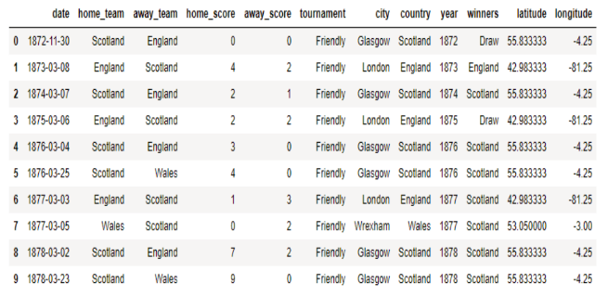

**Geographical Analysis:**

The matches played over the years were analysed based on where the matches were held to understand how diverse the organizers have been in extending the range of the venues. The analysis was done to understand the popularity of the game spread across the world.

The analysis has helped to realize that the football matches have in fact been played around the world in a lot of different countries.

It is seen that most world cup matches have been concentrated mostly in Europe and a little in South America. From this analysis it is realized that maybe if the tournaments like the World Cup is conducted in more places, the Global popularity will rise and there’s a good chance of the quality of Football from these countries will improve exponentially.

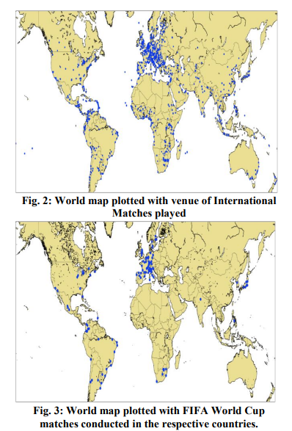

**Statistical Analysis:**

In this analysis, teams are ranked in order of most matches won over the years. Tournament matches as well as the Friendly Matches. This analysis doesn’t necessarily tell us which teams are the best given that friendlies are also considered.

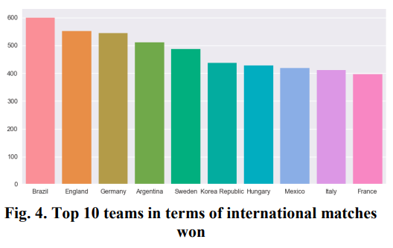

Another analysis was done to understand how the top teams have progressed over the years to get to where they are now. England and Scotland, being the very first teams to play an international match, started out in 1872 and have had a steady rise to the top. Around 1948 Scotland started lose its momentum and slowed down compared to England. Argentina and Uruguay started playing in the mid-1910s and Argentina has seen a very good rise to the top and Uruguay has been relatively slow. Brazil of course, has also made it to the top with a steady rise having started in the mid-1910s. Of the top 10, Korea Republic started the latest, mid-1950s, and has made it to the top 4 very quickly. It has seen the fastest growth of the rest of the teams.

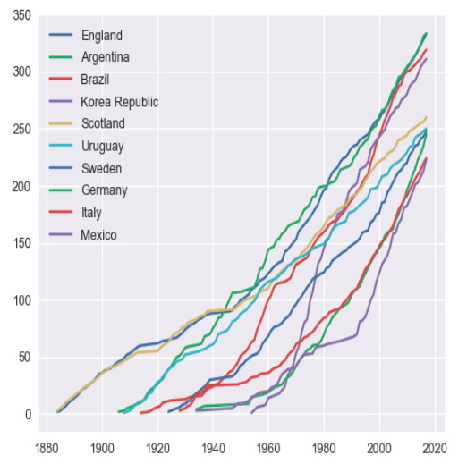

We wanted to understand how the tendency of playing friendly matches has changed for teams over the decades. With this analysis it can be seen that the idea of playing friendly football matches started to catch on in 1920s. From then there has been a zigzag rise in the number of Friendlies played per year. In mid-2000s the world has seen the greatest number of Friendly matches played in a year, that’s slightly 400 matches. Few of the reasons for playing friendlies could be – exposure, tactical or strategical analysis of the opponent teams or to understand the opposition’s weaknesses.

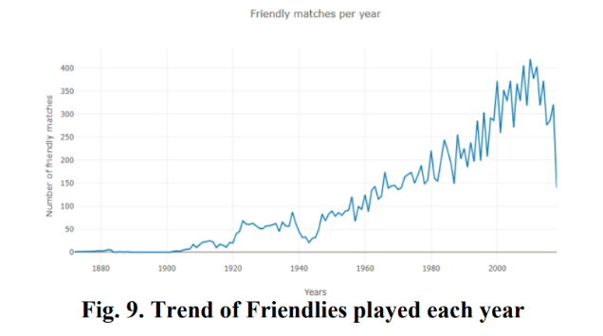

**My critiques and improvements:**

One of the biggest critiques I have with this study is that I feel it is too simplistic to say that holding friendly matches will increase the quality of football in that country. One of the biggest indicators would be the United States where a lot of friendly matches occur, yet the quality and standard of football in that country is not as high as it should be. Also, this study only goes through international matches whereas I strongly believe that club football matches are the most capable of garnering interest in the sport. This is the improvement that I like would suggest that analytics on club football would be more indicative about interest rates in football in different parts of the world.

**Conclusion:**

The game of football has been analysed in terms of geography, its top teams on the basis of different aspects, we have analysed their progress over the years and understood how these teams have performed in comparison to other teams that are as good as them. We have also made a comparison between teams in the top 10 and teams that are rather average. We have analysed the trends of Friendly matches played over the years helping us understand that teams around the world have realised that playing friendly matches with their oppositions is quite fruitful. We have seen that the most of the top 10 teams have more or less had big tournaments such as the FIFA World Cup in their home country. This has helped us realise the importance of conducting such tournaments in countries that are less productive in the game of Football. This can inspire and motivate more players to dream bigger and perform better.

**Done by: -**

**Siddharth Nair (PES2UG20CS339)**